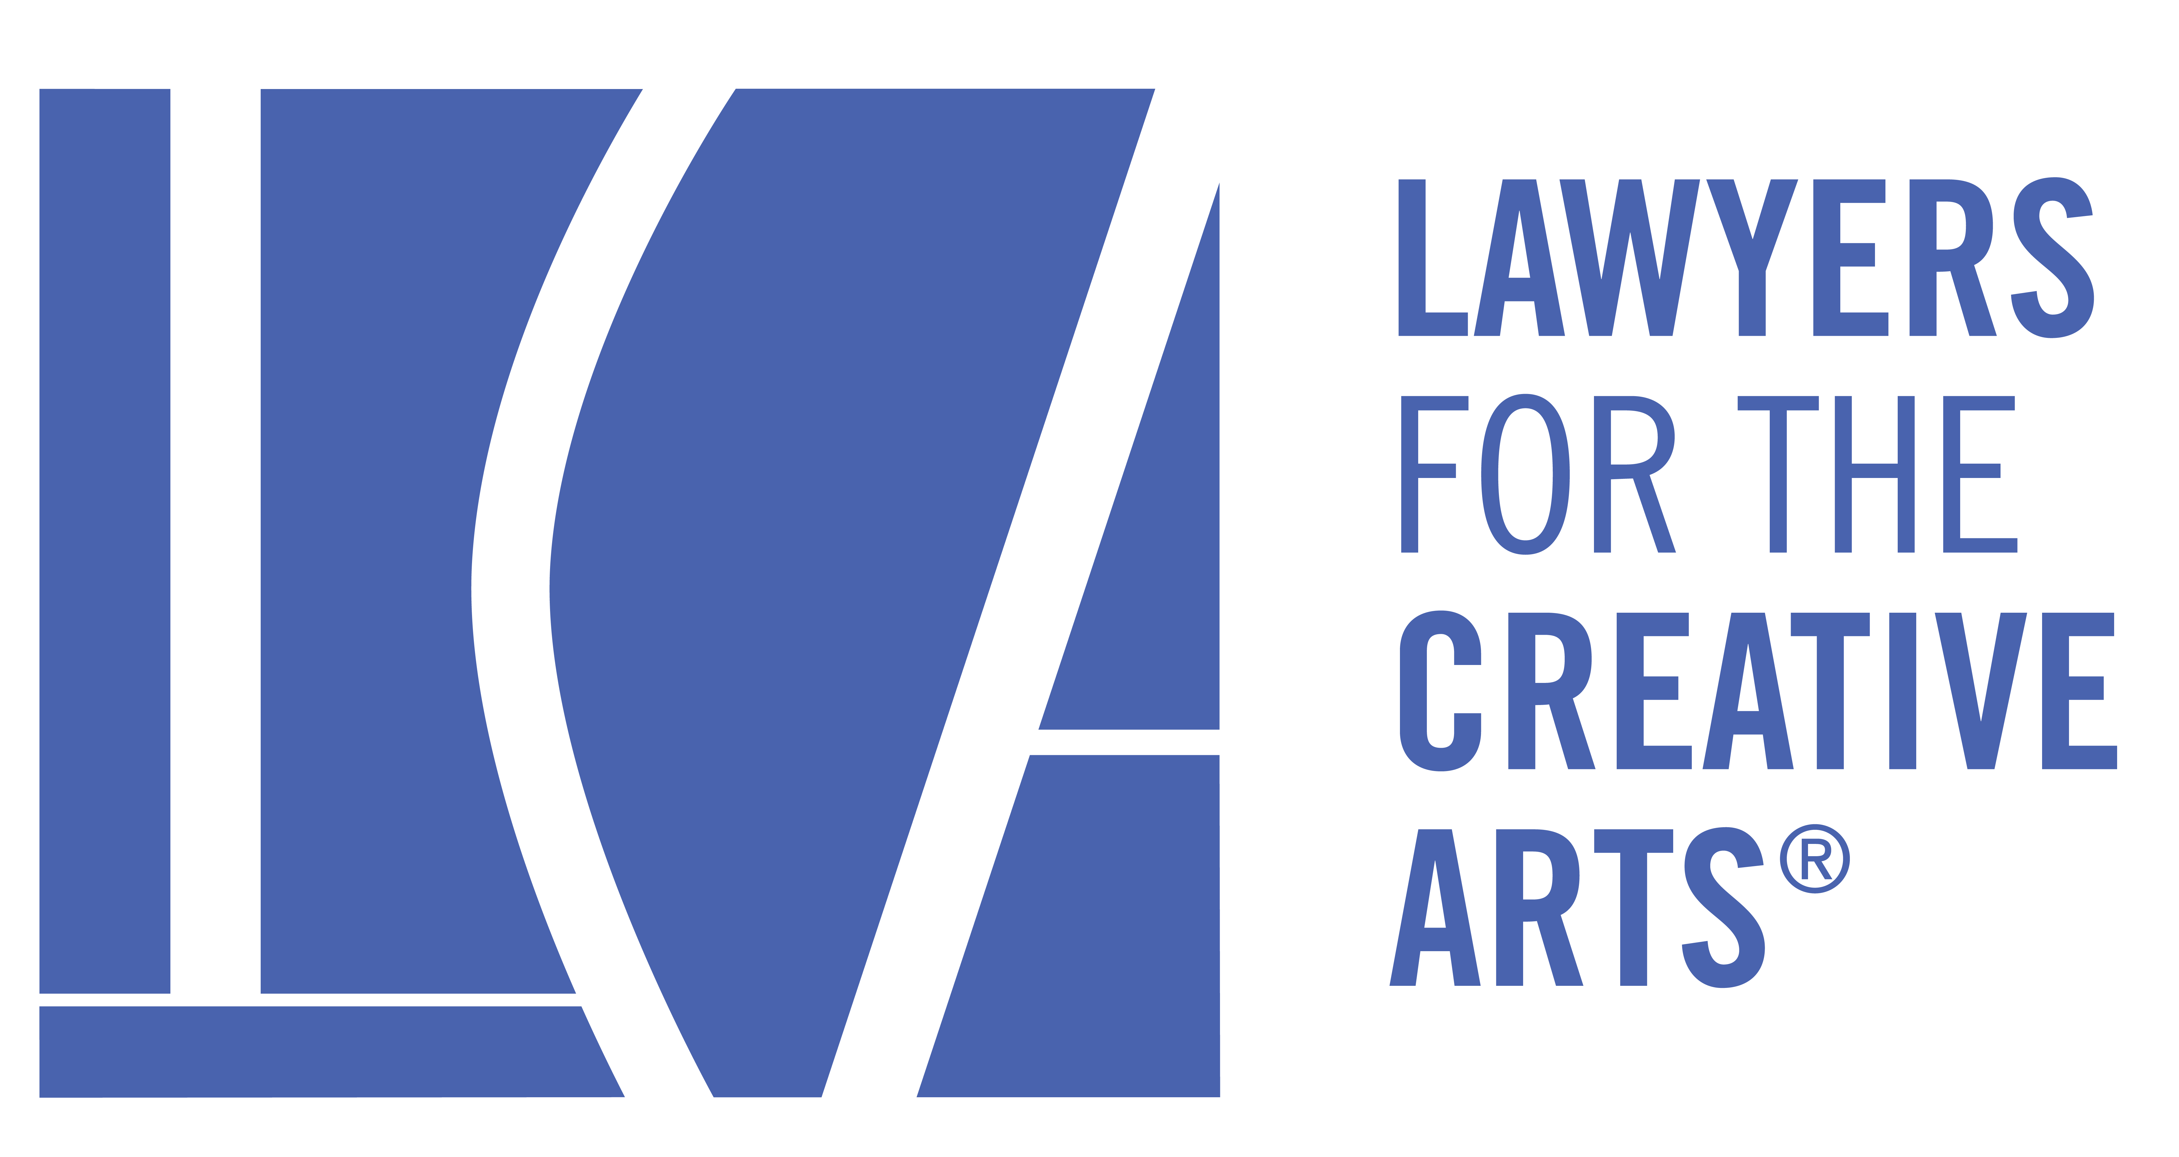

161 North Clark Street, Suite 4300, Chicago, Illinois 60601

Associate Board

New Board Member Information

Revised October 2022

Lawyers for the Creative Arts

In 1972, a group of young lawyers formed what they called the "Creative City Committee" to determine ways to work more closely with the life of the city. They targeted the artistic community, and created a pro bono art and law organization, Lawyers for the Creative Arts. Its mission: to provide legal assistance to artists and arts organizations financially unable to retain legal counsel.
Under the leadership of its first president, James N. Alexander, and first full-time executive director, Thomas R. Leavens (both still actively involved with LCA), LCA soon boasted a $38,000 budget. Fifty-three volunteer attorneys processed 100 matters. Since that start, LCA has mushroomed, enlisting more than 1,800 lawyers to provide pro bono assistance to our thousands of clients.
In addition to providing legal assistance, LCA now conducts workshops on not-for-profit incorporation and tax exemption, organizes seminars pertaining to music, publishing, film, copyright and other areas, and mentors young attorneys. In the past twelve months, LCA has provided service, in one form or another, to over 2,000 people and organizations in all areas of the arts.

Mission

Legal advice is a necessity for all businesses, including the arts business. The problem is that most artists cannot afford market rate legal services. That’s where LCA comes in. LCA is the only pro bono legal service organization in Illinois, specialized, and expert in, all areas of the arts.

LCA Programs

Throughout the year, LCA conducts various seminars and educational lectures pertaining to music, publishing, film, copyright and other areas. Please visit http://www.law-art.org/ for more details.
Associate Board - Information

Membership:

The LCA Associate Board is geared towards young professionals (including attorneys), artists and patrons who share a commitment to LCA and its mission. Membership offers an exclusive calendar of networking and educational events designed to help broaden members’ understanding of arts and entertainment law.

The LCA Associate Board supports LCA and its Board of Directors by taking on key responsibilities in the areas of fundraising and development. The Associate Board believes the engagement of new attorneys, professionals and creative artists and entertainers will not only increase awareness of LCA’s programs and services, it will also provide LCA with direct and tangible benefits through its fundraising efforts.

Associate Board Structure:

Executive Committee

The Associate Board has an Executive Committee comprised of four Officers consisting of a President, Vice President, Secretary and Treasurer, and four to six At-Large Members to carry out Board duties. The Executive Committee runs on the calendar year and all Executive Committee Members are elected by the Associate Board membership for a two-year term. Officer positions have a term limit of four years, or two terms, each for any one individual. Any out-going President will automatically be appointed to an At-Large Member position for the term after their presidency, to help with the transition.

All Executive Committee Members, besides the President and At-Large Member out-going/most recent past President, are required to Chair one Committee during their two-year term. Chairs will be selected using a method at the President’s discretion. Chair terms coincide with the Executive Committee Member two-year term.

Should a vacancy on the Executive Committee arise for any reason, the President may appoint any interested Associate Board Member who is in good standing to fill the position through the remainder of the current two-year term. Should a vacancy arise in the role of the President, the Vice President will assume the role of the President for the remainder of the current two-year term.

Associate Board Members

Associate Board Members are the linchpins of the Associate Board, as they comprise the face and voice of Lawyers for the Creative Arts in the community. Associate Board Members are elected for a one-year renewable term, and it is expected that upon resignation an Associate Board member will recruit or nominate a suitable replacement, should they not wish to renew their membership.

Legal Responsibilities:

Under well-established principles of nonprofit corporation law, a board member must meet certain standards of conduct and attention in carrying out his or her responsibilities to the organization. Several states have statutes adopting some variation of these duties, which would be used in court to determine whether a board member acted improperly. These standards are usually described as the duty of care, the duty of loyalty and the duty of obedience.

Duty of Care

The duty of care describes the level of competence that is expected of a board member, and is commonly expressed as the duty of "care that an ordinarily prudent person would exercise in a like position and under similar circumstances." This means that a board member owes the duty to exercise reasonable care when he or she makes a decision as a steward of the organization.

Duty of Loyalty

The duty of loyalty is a standard of faithfulness; a board member must give undivided allegiance when making decisions affecting the organization. This means that a board member can never use information obtained as a member for personal gain, but must act in the best interests of the organization.

Duty of Obedience

The duty of obedience requires board members to be faithful to the organization's mission. They are not permitted to act in a way that is inconsistent with the central goals of the organization. A basis for this rule lies in the public's trust that the organization will manage donated funds to fulfill the organization's mission.

Associate Board Member Commitment:

Every Associate Board member will be expected to fulfill the following obligations:
- Remit dues to the Associate Board Treasurer (or as otherwise directed) in a timely fashion;
- Attend at least two of the quarterly All-Member Associate Board meetings;
- Serve on one Associate Board Committee, and actively assist that committee in the execution of its objectives;
- Attend the Annual Associate Board Shindy Fundraiser;
- Attend at least one Associate Board event planned by a Committee you are not assigned to and that is separate from the annual Shindy;
- Actively engage the community and professionals, increasing the awareness and interest in Lawyers for the Creative Arts, in person and through all forms of media.
- Accept at least one matter from the Lawyers for the Creative Arts case list per year.

Case Acceptance Requirement:

Any member of the Associate Board shall be required to accept one (1) matter from the Lawyers for the Creative Arts case list per calendar year. For existing Associate Board Members, the calendar year begins on January 1. For new Associate Board members accepted after this date, their calendar begins on the day in which they have been accepted as a member of the Associate Board. Failure to accept and complete one (1) matter within one calendar year term may constitute grounds for dismissal from the Associate Board.

The following categories of Associate Board members shall be exempt from the annual case acceptance requirement: law students, employees of educational institutions, and non-lawyers/non-practicing lawyers. Additionally, lawyers currently working as in-house counsel are strongly encouraged, but not required, to accept a matter from the LCA case list. Any Associate Board Members who do not fall into the above categories should contact the Associate Board President and Vice President for a case-by-case determination as to the applicability of the case acceptance requirement related to their membership on the Associate Board.

Any law student member of the Associate Board, while not subject to the yearly case acceptance requirement, may be asked to conduct research for practicing attorney Associate Board members in order to assist in LCA matters. Any practicing attorney Associate Board member who seeks the assistance of law student members for research agrees to hold any law student Associate Board member harmless regarding the quality of the research and shall do so with the understanding that said research is not to be exclusively relied upon and is merely a tool in assisting and providing quality counsel to LCA clients.

Case Assistance Program

The Associate Board Case Assistance Program is designed to provide assistance and mentorship for Associate Board members who take on matters that present them with new challenges or general unfamiliarity in an area of law. The Case Assistance Program shall consist of a roster of mentors. Service as a Mentor in the Case Assistance Program shall exempt Associate Board members from the yearly case acceptance requirement provided they assist with one (1) matter per year through the Case Assistance program. Members wishing to serve as a Mentor may express interest to the President, Vice President, and Case Assistance Program Chair. In order to qualify as a Mentor, an Associate Board member must maintain an active license to practice law. Further, mentorship status is to be determined by a majority vote conducted by the Associate Board President, Vice President, and Case Assistance Program Chair. Members wishing to step down from their role as a Mentor must provide written notice to the Associate Board President, Vice President, and Case Assistance Program Chair. Membership on the Associate Board is not a pre-requisite for serving as a Case Assistance mentor, but use of the Case Assistance Program is restricted to only Associate Board members.

Program Chairs:
- Ilya Zlatkin – ilya@zce.law
- Grace Trotter – gracegtrotter@gmail.com

Dues

The Associate Board runs on a fiscal year from July through June. Membership requires a minimum donation, with the additional expectation to buy and sell tickets at fundraisers and seek out sponsors for the organization and events. Associate Board dues break down as follows:

$250 (attorneys)
$150 (non-attorneys/public interest or government attorneys)
$75 (law students)

Associate Board dues are an imperative part of LCA’s income. We appreciate them being paid in a timely manner.

*If you find yourself unable to make timely payment or otherwise experiencing undue financial hardship and in need of some assistance, please contact the current Associate Board Treasurer to set-up a payment plan or other mutually agreeable arrangements.

Associate Board Member Benefits:

Upon receipt of your Associate Board dues, your membership benefits include:
- Free admission to the Annual Associate Board Shindy Fundraiser;
- Free access to the Associate Board Members-Only Educational Workshop;
- Discounts to LCA Events when available;
- Networking opportunities with industry professionals;
- Invitation to the LCA Holiday Party;
- Resume booster and chance to enhance your soft skills and leadership abilities

Committees

Currently, the Associate Board has six committees: Community Service/Outreach, Education, Events, Recruitment, Shindy and Social Media. Members are required to serve on one committee during each year of their membership. You will be assigned to a Committee as part of your admission process into the Associate Board. All Associate Board Members will be eligible to make a request to change their Committee assignment at the beginning of each fiscal year, provided they have served on their current Committee for at least one year. Procedural details for doing so will be provided to the Associate Board membership by the Vice President.

Community Service/Outreach Committee:

The Community Service/Outreach Committee is tasked with providing our membership the opportunity to assist other groups or organizations in need, preferably groups that have a similar mission or are otherwise related to the arts. The committee must plan at least (1) community service/outreach event each year.

Committee Chair:
(1) Aaron Kacel – akacel@robbins-schwartz.com

Education Committee:

The Educational Committee is responsible for planning educational programs for artists focusing on legal concepts and/or continuing legal education programming for LCA volunteers and the legal community at large. The committee must plan at least (1) educational event for the larger community and at least (1) Associate Board Members-Only educational workshop each year.

Committee Chair:
(1) Amanda Alasauskas - aalasauskas@smbtrials.com
(2) Kahlia Halpern - khalpern@gbc.law

Events Committee:

The Events Committee is tasked with creating and organizing social, networking and fundraising events for LCA. Throughout the year, the Events Committee will work to develop creative events that are of interest to LCA’s clients, volunteers, and Board Members, as well as to the public at large. The committee must plan at least (2) events each year.

Committee Chair:
(1) Alex Karana - akarana@vonbriesen.com
(2) Mark McLoughlin - mmcloughlin@smbtrials.com

Recruitment Committee:

The Recruitment Committee shall market, advertise and conduct public relations work on behalf of the Associate Board in an effort to grow the Associate Board Membership. The committee must plan at least (1) recruitment event each year.

Committee Chair:
- RJ Currington - rjc@curingtonlaw.com

Shindy Committee:
Each year, the Associate Board hosts the “Shindy,” a networking and fundraising opportunity for our artistic community. It is usually a festive evening filled with food, drink and live entertainment and presents an opportunity to not only raise money for LCA, but for members of the arts to meet and mingle with one another. This is the Associate Board’s biggest fundraiser of the year for LCA.

Committee Chairs:
(1) Brett Manchel - manchel.brett@gmail.com
(2) Alexa Tipton - atipton@irwinip.com

Social Media Committee:

The Social Media Committee is tasked with keeping apprised of legal news relevant to the LCA organization and its members, and assisting with various social media-centric projects focused on supporting the arts community, LCA as a whole, and the Associate Board specifically. The committee shall compile a list of news articles to create and generate posts to be shared across LCA's social media platforms on a regular basis. The committee will contribute and edit content, secure additional content contributors as needed, and promote LCA programs and events across all media platforms.

Committee Chair:
(1) TJ Kliebhan - tkliebhan@smbtrials.com

Key information

LCA Mailing Address:

161 North Clark Street

Suite 4300

Chicago, Illinois 60601

312.649.4111

www.law-arts.org

Associate Board Email Address: associateboard@law-arts.org

2023-2025 Executive Committee

Amanda Alasauskas, President, aalasaus44@gmail.com

TJ Kliebhan, Vice President, tkliebhan@smbtrials.com

Aaron Kacel, Secretary, akacel@robbins-schwartz.com

Brett Manchel, Treasurer, manchel.brett@gmail.com

Alex Karana, akarana@vonbriesen.com

Alexa Tipton - atipton@irwinip.com
RJ Currington - rjc@curingtonlaw.com
Mark McLoughlin - mmcloughlin@smbtrials.com
Kahlia Halpern - khalpern@gbc.law
Ilya Zlatkin – ilya@zce.law
Grace Trotter – gracegtrotter@gmail.com

Nourishing the creative spark! ®

MEMBERSHIP ACCEPTANCE AND DUES

The Lawyers for the Creative Arts Executive Board would like to formally extend to you an invitation to join its Associate Board. The main goal of the Associate Board will be to spread the word of Lawyers for the Creative Arts in the community, as well as raise funds in order to ensure that the organization’s mission is successful. With your help, we will accomplish these goals through social, educational and networking activities and opportunities for our Associate Board Members, the general public, and artists all around Chicago.

This invitation is for a one-year membership and in order to effectuate acceptance of your invitation, you must sign and date below. The fees are as follows:

Attorney – $250/year
Non-Attorney/Public Interest or Government Attorney – $150/year
Law Student – $75/year

By signing below, you indicate that you accept the invitation to join the Lawyers for the Creative Arts Associate Board. In addition, you agree to remit payment of your tax-deductible, annual membership dues in full, or alternatively, make other arrangements with the Associate Board Treasurer to pay your annual dues.

Please remit this signed acceptance form to associateboard@law-arts.org and pay your dues online here: https://law-arts.org/associate-board-membership.

If you choose to pay your dues by check, you can make the check payable to Lawyers for the Creative Arts, write “Associate Board Dues” in the memo line, and mail to the address below. When mailing your annuals dues, please mark the envelope: Personal & Confidential.

After submitting your annual dues, you will receive a letter from Lawyers for the Creative Arts confirming that your dues are tax-deductible. Please feel free to contact the Associate Board Treasurer with any questions or concerns.

___________________________ __________________________
Printed Name Signed Name

Date:

Lawyers for the Creative Arts, 161 North Clark Street, Suite 4300, Chicago, Illinois 60601
Phone (312) 649-4111 Fax (312) 944-2195

